


Committee on Committees Minutes

Associated Students
DATE: January 26th, 2026
LOCATION: Pardall Center Minutes/Actions recorded by: Shuyi Sum

CALL TO ORDER: 6:17 by Lily Strange, Internal Chair

QOTW: When was the last time you saw snow?

A. MEETING BUSINESS

- Roll Call

Name | Note:  absent (excused/not excused)  arrived late (time)  departed early (time)  proxy (full name) | Name | Note:  absent (excused/not excused)  arrived late (time)  departed early (time)  proxy (full name)
Sophia Fei | Present | Yeshua Valdez Rodriguez | Present
Lily Strange | Present | Savanah Lizet Aldaba | Present
Shuyi Sum | Present | Adam Orenstein | ...
Oliver Ramirez Carrera | Present | Rylee Bones | Present
Layla Hakim | Present | Archish Prakhya | Present
Mira Ikladious | Excused

- Acceptance of Excused Absences

MOTION/SECOND: Oliver/Shuyi
Motion Language: Motion to excuse Mira from tonight’s meeting, January 26th.
ACTION: Consent

- Acceptance of Proxies

B. PUBLIC FORUM

- EXTERNAL REPORTS

- Advisor’s Report

- Executive Officer’s Report(s)

- Group Project/Member Report(s)
  - Advisor and Senate Liaison Reports

Lily Strange - Internal Chair
    - QOTW: That weird hailstorm last year (?) ..but I will be in the snow next week 😋
    - Budget update → ledger
      - Please update with your requisition amount after submitting
    - 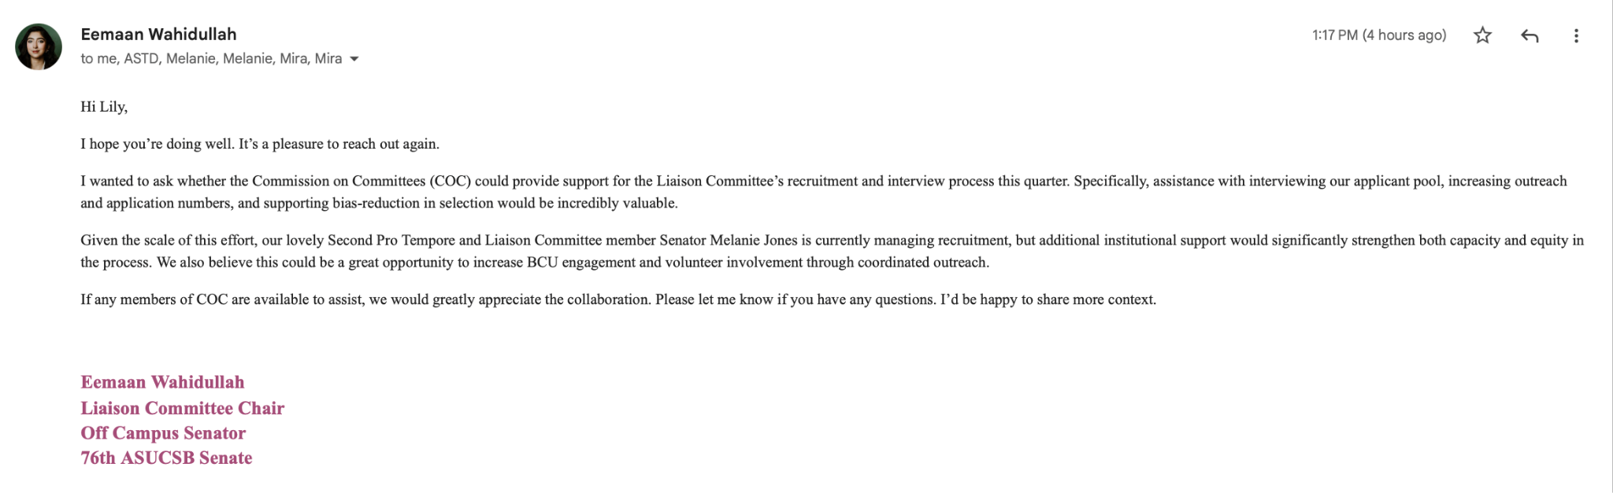
      - Liaison committee hiring → in the upcoming week(s)
    - AS Olympics (AKA SQUID GAMES)
      - Planning brainstorm:
        - Bouncy house obstacle course
        - IV drip cookies, star, triangle, etc
        - Raffle gift cards
        - Free lunch/dinner
        - Tug of war
        - Red light green light
      - Anyone want to take lead on the legal code bill for this?
        - Oliver
    - UCSB Career Center update!
      - Ideas!?

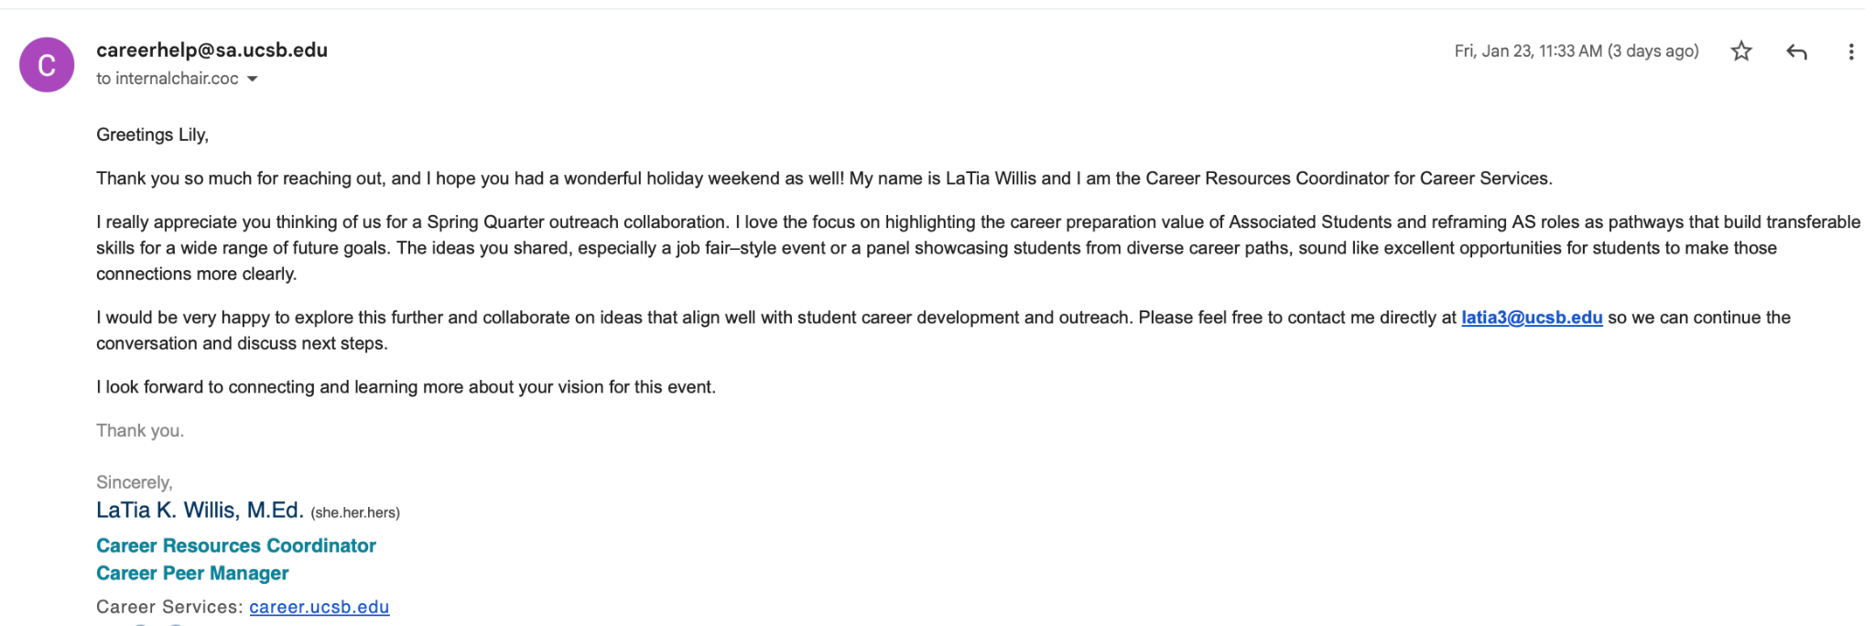
    - Voting to resign and appoint
    - Mailing a list of students… can someone directly connect them to all external forms taking applications + email if interested in office of senate leadership
      - Layla
    - Retreat - Monday Feb 9th
      - Location TBD
        - Arnoldi’s Cafe

Sophia Fei - External Chair
    - Qotw: last year i went skiing in big bear
    - Coc budget??
      - Fill out 3 requisitions (chilis, costco, target) - do i fill out the pdf or do the online survey sent out???
    - Interviewed for OSA and OSL
    - I am now AUTHORIZED 😎
      - 🔥- Shuyi
    - PLAN RETREAT THIS WEEEEK
      - Pass money for last quarter retreat…
      - 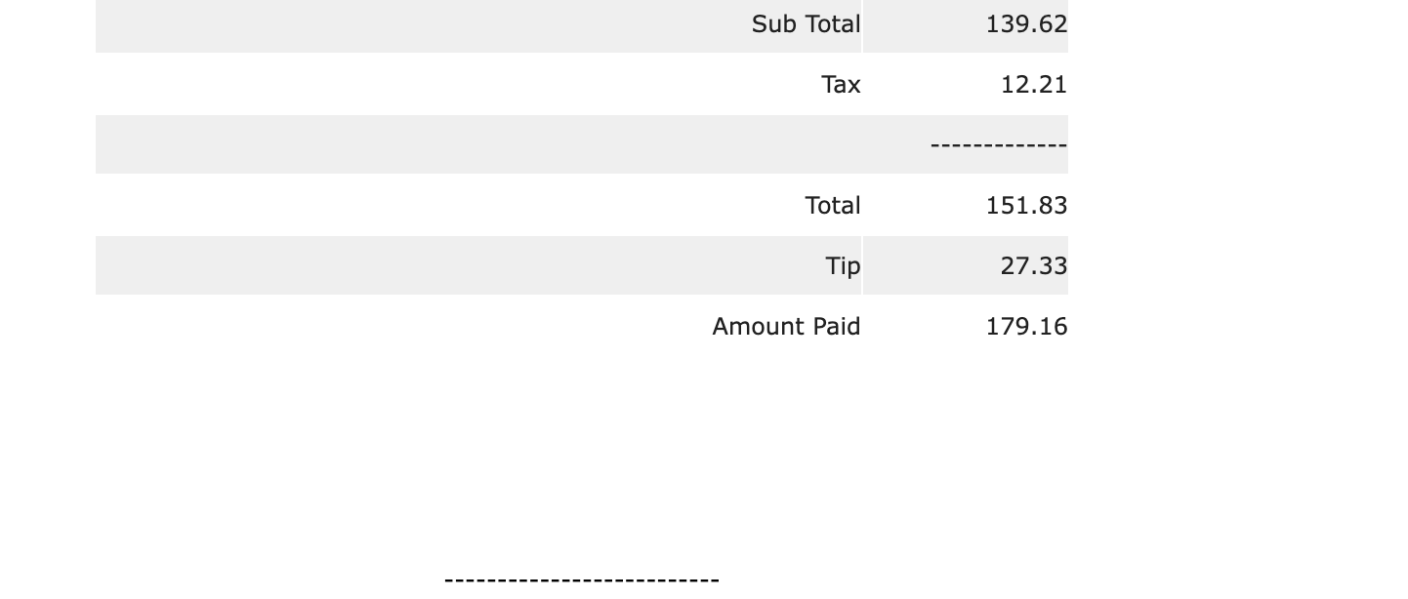

Shuyi Sum - Vice Chair
    - QOTW: ~2ish years ago in Lake Tahoe !
    - Interviewed Baleigh for OSL 👍
    - Eemaan/Liaison Committee email/scheduling support - noted 👍
    - Tabling w Le Anh - signups
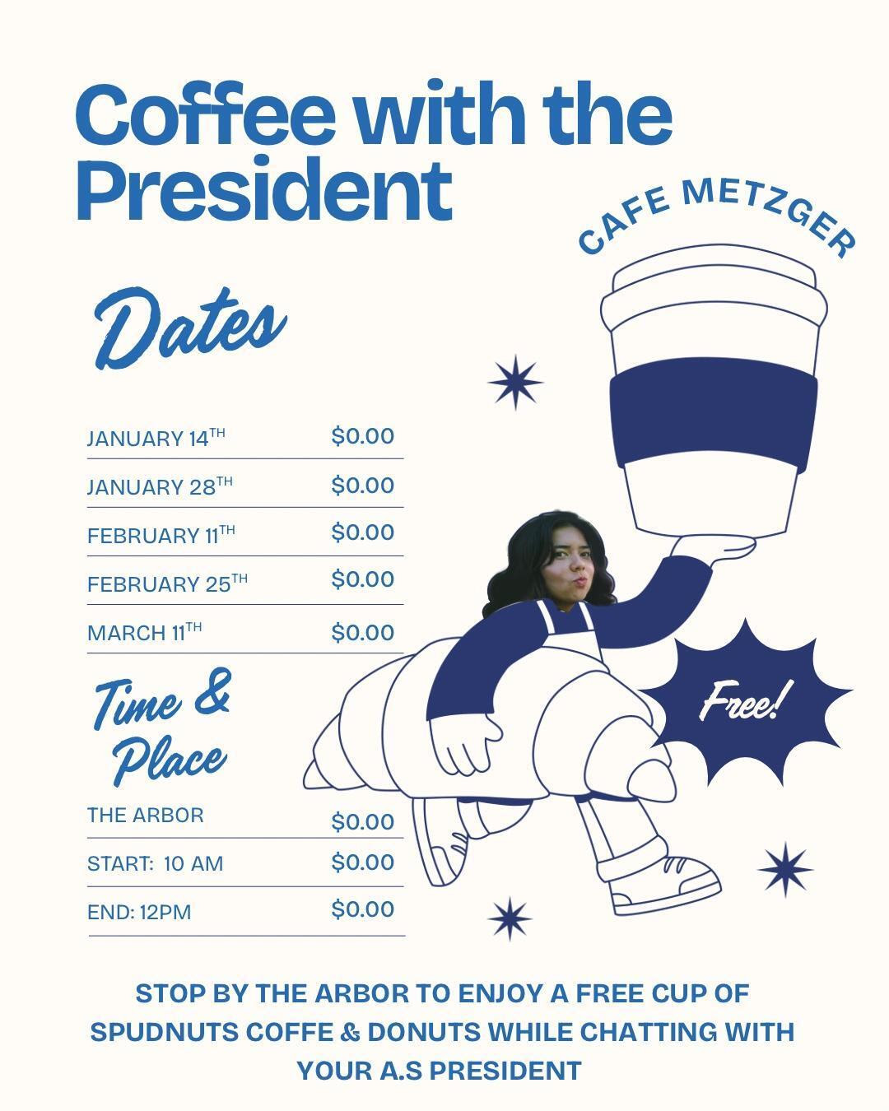
- WEDNESDAYS 10AM-11AM OR 11AM-12PM
- 2/11: Oliver Ramirez Carrera (10-11AM)
- 2/25: Yeshua Valdez Rodriguez (10-11 am)
- 3/11:
    - Brunch retreat still tbd ?

Oliver Ramirez Carrera - Internal Liaison
    - QOTW: This last winter break
    - Sent out an email reminding BCUs to fill out the recruitment spreadsheet
    - Interviewed w/ Shuyi and Rylee regarding the office of senate leadership position
    - Also had a Campus Elections Committee meeting this past Tuesday, it was the first meeting of the quarter
      - Talked about voter language, make small changes to ensure language is understood
    - I can do coffee w/ the president 2/11 from 10-11am
    - I can also take lead on the legal code bill for the AS Squid Games

VACANT - Internal Liaison

Layla Hakim - Outreach and Recruitment Coordinators
    - QOTW: this winter break at my grandparents house in NY
    - Sent out emails promoting open positions for I think the last four BCUs on the open positions spreadsheet, a lot of departments sent them out this time I think
    - Made new fliers for these positions as well, can adjust them accordingly if any positions are filled
    - Working on making an event, but have a few questions
      - Vision board event magazines?
      - Valentine's card making maybe instead?
        - How would we relate this to AS though
        - Maybe bouquet making?

Mira Ikladious - Outreach and Recruitment Coordinators

Yeshua Valdez Rodriguez - Outreach and Recruitment Coordinators
    - QOTW: Last time I saw snow was last year’s winter break, where I went to the sequoias with a few friends
    - Website Update
      - The website is still under development
      - Alex had to meet with Sean given the old code, and ran into some problems during winter break
      - He said that the final draft should be ready in a week or two, and he’ll send it over as soon as it’s done

Savanah Lizet Aldaba - Outreach and Recruitment Coordinators
    - QOTW: During winter break, it was snowing in Washington
    - Interviewed Jacob for OSA and OSL with Sophia and Rylee
    - Coffee with the president 1/28 from 11-12pm.

Adam Orenstein - Commissioner of Community and Climate

Archish Prakhya - Pearman Fellow
QOTW: The last time I saw snow was during a visit to Chicago last winter to attend an orchestra concert for my sister
Attended the Pearman Fellowship Group Meet with other internal Pearman fellows today and brainstorming ideas for the final Pearman Fellow Final Project.
Schedule time to shadow interview events throughout and schedule coffee time!

Rylee Bones - Pearman Fellow
i. QOTW: I saw snow when I was home over winter break on my drive to go on a hike!
ii. Shadowed interviews for Jacob and Bailey
iii. Schedule time with Mira for the coffee event for week 6 and reserve a spot

C. Action Items

- ACCEPTANCE of AGENDA/CHANGES to AGENDA

- CONSENT ITEMS

- Approval of our Action Summary/Minutes from:

- ACTION ITEMS

F-1. Old Business:

F-2 New Business:

- DISCUSSION ITEMS

- Discussion Topic

- REMARKS

- ADJOURNMENT

MOTION/SECOND: Savanah/Rylee
Motion Language: Motion to resign Paula Tillotson from the AS Committee on Committees Internal Liaison position. See text resignation below (we were unable to obtain an official email resignation despite requested).
ACTION: CONSENT
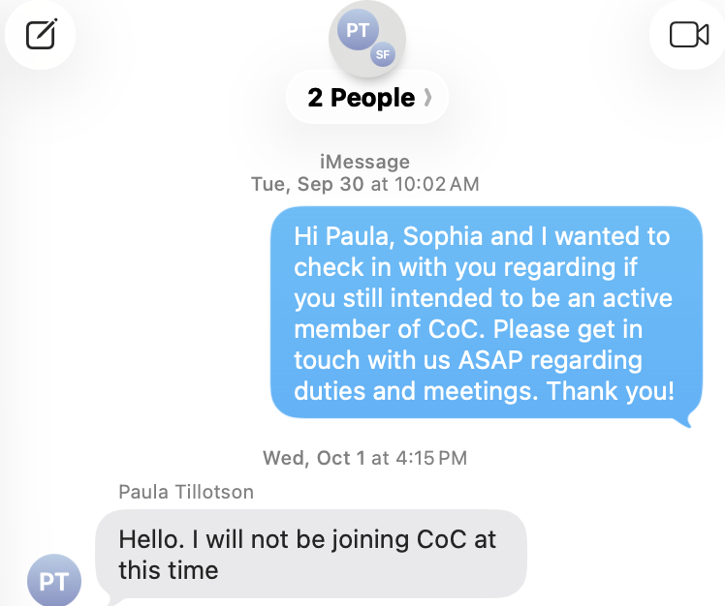

MOTION/SECOND: Oliver/Shuyi
Motion Language: Motion to appoint Rylee Bones to the AS Committee on Committees Internal Liaison position for the Winter 2026 quarter and terminate her Pearman position due to transferring schools after the Winter 2026 quarter.
ACTION: CONSENT

MOTION/SECOND: Oliver/Layla
Motion Language: Motion to pass $179.16 for the Fall 25 CoC board retreat at Chili’s.
ACTION:CONSENT

MOTION/SECOND: Shuyi/Yeshua
Motion Language: Motion to adjourn this meeting at 6:48PM.
ACTION: CONSENT

